

TITLE:
MOBILE APP DEVELOPMENT PROCESS
CEF 440, Internet programming and Mobile Programming
Lecturer: Dr Valery Nkemeni
Report by Group 21

S/N | NAME | Specialisation | Matricule
1 | CHE RANDY FANG | Software | FE23A030
2 | ECHUNDIP CARL-LAWRENCE N. | Networking | FE23A040
3 | MAKANE THANKS MOSAKA | Software | FE23A085
4 | NUMFOR PRECIOUS LUM | Software | FE23A126
5 | TEMFA NKOMBONG FORTUNEE | Software | FE23A168

Table of Contents
I. App Identity: 3
1. App Name and Tagline 3
2. App Icon 3
3. Colour Palette 4
4. Typography 4
5. Logo 4
6. Tone of Voice 5
II. Design Implementation of System 5
a. ADMIN Panel: 5
❖ Overview & System Purpose 5
❖ System Health & Infrastructure Monitoring 7
❖ Platform-Wide Analytics & Quality of Experience 8
❖ Course & Content Supervision 10
b. Instructor’s Pannel 11
❖ Overview of the Instructor Dashboard 11
❖ Header and Welcome Section 11
❖ Statistics Overview Cards 12
❖ Your Courses Section 12
❖ Recent Uploads Activity Feed 12
❖ Overall User Experience Benefits 12
❖ Conclusion 13
c. Student Panel: 13
❖ User Interface Design 14
❖ Courses Page 15
❖ Assignments Page 15
❖ Messages Page 16
III. Conclusion 18

TASK 5: UI DESIGN AND IMPLEMENTATION IN GETTING THE APP IDENTITY

App Identity:

1. App Name and Tagline
The application is named EduStream. "Edu" immediately signals the academic purpose, while "Stream" reflects the platform's core innovation: adaptive content streaming. The name is short, bilingual-friendly, and suitable for app store listings and launcher labels.
The official tagline is: Learn Without Limits. This speaks directly to the platform's mission of removing network and connectivity barriers to education.

2. App Icon
The icon combines an open book (knowledge, learning) with an upward signal wave (connectivity, adaptive streaming), rendered in white and a Sky Blue-to-Teal gradient on a Deep Navy-Blue background.
- Canvas: 1024 × 1024 px master; Android Adaptive Icon format (foreground 108 × 108 dp, safe zone 72 × 72 dp).
- Background: Deep Navy Blue (#0D2B55). Book in white; wave in #1E88E5 → #26C6DA gradient.
- Notification icon: 24 × 24 dp monochrome outline. Launcher minimum: 48 × 48 dp.
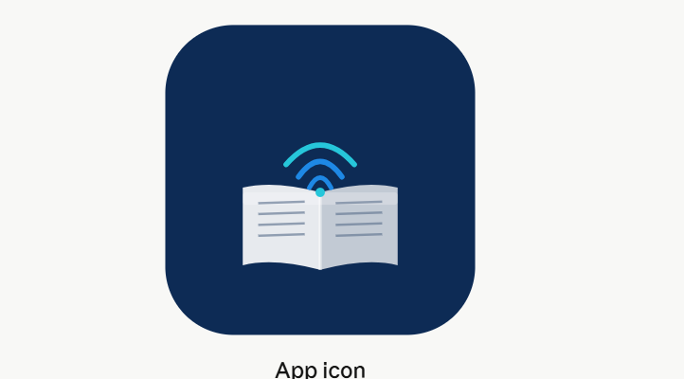

3. Colour Palette
The palette meets WCAG 2.1 AA contrast requirements and is designed to function in bright outdoor environments common in low-resource settings.

Colour | Hex | Usage
Deep Navy Blue | #0D2B55 | App bar, headers, primary buttons
Vibrant Sky Blue | #1E88E5 | Links, active tabs, icons
Soft Teal | #26C6DA | Progress bars, badges, highlights
Light Surface Grey | #F5F7FA | Screen backgrounds
Charcoal | #212121 | Primary body text
Success Green | #43A047 | Quiz pass, completion states
Warning Amber | #FB8C00 | Low bandwidth alerts
Error Red | #E53935 | Connection loss, errors

4. Typography
Primary Typeface: Poppins (Google Fonts, Open Font License)
Poppins is a geometric sans-serif chosen for its modern appearance, excellent small-size legibility on low-resolution screens, and full weight range. Roboto serves as the Android system fallback, ensuring readability even in zero-connectivity scenarios.

Style | Size | Weight | Usage
Headline 1 | 32sp | Bold | Screen titles, course names
Headline 2 | 24sp | Semi Bold | Section headers
Body | 16sp | Regular | Main content text
Caption / Label | 12sp | Medium | Tags, timestamps, badges
Button | 14sp | Bold | All interactive buttons

5. Logo
The logo places the icon mark to the left of the wordmark (Poppins SemiBold). "Edu" is set in Deep Navy Blue and "Stream" in Vibrant Sky Blue to reinforce the brand's dual identity. The tagline appears below in Poppins Regular, Medium Grey.
- Minimum width: 120 px (digital) / 35 mm (print).
- Clear space: equal to the cap-height of the "E" on all four sides.
- Variants: full-colour (light backgrounds), reversed white (dark/navy backgrounds), monochrome, icon-only, wordmark-only.
- Never stretch, recolour outside approved variants, or place on low-contrast backgrounds.


6. Tone of Voice
EduStream speaks to users in a voice that is encouraging, clear, and inclusive. Technical processes are communicated in plain language:
- Low bandwidth detected → "Switching to audio mode to keep you learning."
- Quiz submitted → "Well done! Your answers have been saved."
- Offline mode → "You're offline. Progress will sync when you reconnect."

Design pattern and architecture

Our Adaptaptive e-learning platform EduStream addresses the unique challenges, such as offline functionality, and multi-institutional scalability.

For our Architecture, we are going with a combination of clean architecture and MVVM.
Clean Architecture organizes the system into concentric layers (Entities, Use Cases, Interface Adapters, and Frameworks), ensuring that the core business logic is independent of the UI, database, or external agencies. In EduStream, the decision to switch from video to audio due to low bandwidth is a business rule. Clean Architecture places this logic in the Domain Layer (Use Cases).The UI (Student Panel) doesn't need to know how the bandwidth is measured; it simply reacts to the data provided by the core. This makes the "Learn Without Limits" mission technically robust.

Considering the platform is built not for a single university but designed for all learning infrastructures in low resource areas of Cameroon. The ability of Clean Architecture to keep the core learning logic (Entities like `Course`, `User`, `Assignments Due`) stable while easily swapping out the "Infrastructure Layer" (e.g., different databases) makes it convenient. The Admin Panel handles sensitive "User Governance" and "Academic Integrity" (plagiarism detection). Clean Architecture allows these complex algorithms to be tested in isolation without needing a browser or a live database, ensuring the platform's academic credibility.

With respect to MVVM it is a design pattern that excels in data-driven applications by separating the UI (View) from the data logic (Model) via a mediator (View Model). The Admin Panel displays dynamic metrics like "Active Now" and "CPU Load." In MVVM, the View Model handles the live data stream from the backend and exposes it to the View. This ensures the UI stays responsive and "clean" (minimalist), even when processing high-frequency infrastructure updates.
The Student Panel aims to reduce visual clutter. MVVM facilitates this by ensuring the View (React components) only contains layout logic. All the "state" (e.g., whether a student is currently offline, their course progress, or message notifications) is managed in the View Model. This prevents the UI code from becoming spaghetti as more features are added.

Since EduStream uses a Single Page Application (SPA) architecture, MVVM is the natural partner. It allows for two-way data binding(or one-way data flow in React terms), ensuring that when a student submits a quiz, the "Success" state updates the UI instantly without a page reload, fulfilling the encouraging and clear tone of voice.

Design Implementation of System
We carried out a thorough design of the entire system using the various properties passed above and came up with the following:

ADMIN Panel:

Overview & System Purpose
EduStream is an adaptive e-learning platform designed for a single university environment, built with future scalability in mind for multi-institutional deployment. The admin dashboard serves as the central command interface through which platform administrators govern every operational layer of the system that is from individual user accounts to server infrastructure health.
The dashboard is designed as a mobile-first application, presented in a clean white and navy-blue aesthetic that balances professionalism with clarity. It is structured around four core operational modules, each accessible via a persistent bottom navigation bar that mirrors the interaction model of modern mobile applications. This keeps the most critical functions always one tap away regardless of context.
The four active modules are User Governance, System Health, Platform Analytics, and Course Supervision. Two additional modules: Institutional Communications and Regulatory Compliance are planned for a future release phase and are currently reserved as placeholder sections in the system architecture.
All data displayed in the current version is simulated with realistic mock values representative of a mid-sized university. When connected to a live backend API, every metric card, chart, user record, server status indicator, and course listing will be hydrated from real-time database queries. The architecture was intentionally designed to make this transition clean so each data source maps directly to a named data object in the codebase, requiring only an API endpoint swap rather than a structural rebuild.
User Governance & Account Management
The User Governance module is the most operationally dense section of the admin dashboard. It gives administrators complete visibility and control over every account on the platform, categorized across three primary roles: Students, Lecturers, and Admins.
At the top of the section, four metric cards provide an at-a-glance snapshot of the platform's user population. The total user count (currently 12,847) tracks platform growth month-over-month. Active Now (1,204) reflects real-time concurrent sessions. Pending (38) flags accounts awaiting administrative review so we could say these are typically new registrations, role-change requests, or accounts that have triggered automated review flags. Suspended (12) tracks accounts that have been restricted due to policy violations.
Below the metrics, a live search bar allows administrators to query users by name, student ID, department, or email address. Results filter in real time as the administrator types, removing the need for page reloads or separate search submissions. Alongside search, a set of filter pills lets administrators narrow the user list by role (Students, Lecturers, Admins) or by status (Active, Pending, Suspended). These filters combine with the search input, so an administrator can, for example, search for "Medicine" and then filter to "Pending" to see only pending medicine students.
Each user row in the list is tappable and opens a full profile modal from the bottom of the screen. The modal presents a structured profile card showing the user's email address, phone number, account creation date, number of enrolled courses or taught courses, total session count, and current account status. Three action buttons are available directly within the modal: Edit (to modify account details), Message (to initiate a direct communication), and a context-sensitive Suspend or Restore button depending on the user's current status. This eliminates the need to navigate to a separate admin panel for routine account actions.
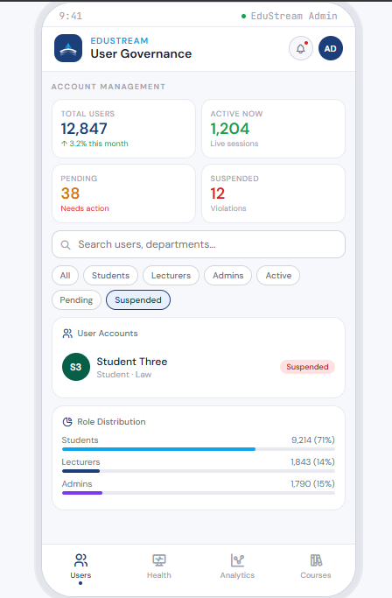
The Role Distribution card below the user list provides a proportional breakdown: 71% of the platform's users are students, 14% are lecturers, and 15% are admins, visualized as horizontal progress bars color-coded by role.

System Health & Infrastructure Monitoring
The System Health module gives the administrator a real-time operational view of the technical infrastructure powering EduStream. This section combines both high-level summary metrics and granular service-level monitoring to ensure that any degradation in platform performance can be identified and acted upon immediately.
The four top metric cards cover the most critical infrastructure indicators. Uptime (99.8%) reflects the platform's reliability over the past 30 days. Average Response Time (142ms) measures how quickly the backend is serving requests to users, with the downward trend (18ms faster than the previous week) indicating recent optimization. CPU Load (67%) indicates the current processing burden across the server cluster, flagged as moderate. Active Sessions (1,204) echoes the user governance count, here presented in an infrastructure context to help the admin correlate user load with system performance.
The Server Status card lists five distinct services, each with a live status indicator. The Primary Database (PostgreSQL) and Media CDN (Cloudflare) are both fully operational. The Auth Service (OAuth2), which handles all authentication and session token management, is also healthy with 2,341 active tokens. The ML Engine which powers the platform's adaptive learning recommendations is flagged with an amber warning dot due to a CPU load of 89%, indicating it is under high demand and may require vertical or horizontal scaling. The SMTP Relay (Postfix), which handles all outgoing email notifications, is currently offline with a queue backlog this is the most urgent operational issue shown in the dashboard.
The Resource Usage section provides a four-metric bar breakdown: CPU at 67% (amber), RAM at 54% (cyan), Storage at 78% (navy, approaching critical), and Network I/O at 33% (green, healthy). The 78% storage utilization is particularly noteworthy for the active alerts card below projects the storage reaching full capacity in approximately 18 days at the current consumption rate, making it a medium-priority action item.
The Active Alerts feed distills all monitored anomalies into three prioritized entries: the SMTP relay outage (critical, 2 minutes ago), the ML Engine CPU spike (warning, 14 minutes ago), and the storage capacity projection (informational, 1 hour ago). This feed is designed to be the administrator's first stop when opening the health tab, providing triage information at a glance without requiring manual inspection of each service row.
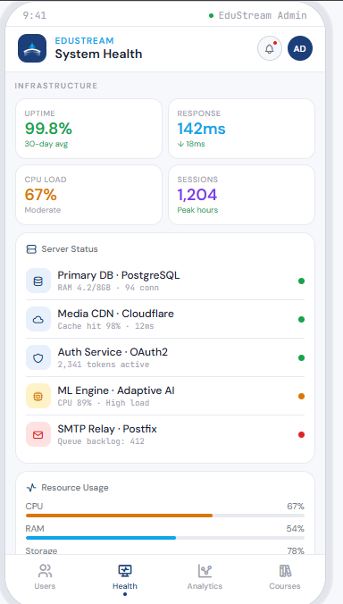

Platform-Wide Analytics & Quality of Experience
The Analytics module measures the qualitative health of the learning experience delivered by EduStream, moving beyond infrastructure uptime into how effectively students are engaging with the platform's content and features.
Four headline metrics frame the section. Average Session Duration (38 minutes) reflects how long a typical user engages with the platform per visit, trending upward by 6% compared to the previous week a positive signal indicating increasing depth of engagement. Course Completion Rate (72%) measures the proportion of enrolled students who finish the courses they begin, up 4 percentage points, suggesting that recent content improvements or adaptive learning interventions are having a measurable impact. Satisfaction Score (4.3 out of 5), derived from 12,041 learner ratings, provides a direct measure of perceived quality. Drop-off Rate (18%), however, is flagged as a concern and now we see it has risen by 2 percentage points, meaning a growing proportion of students are abandoning courses mid-way through, likely warranting a content quality review for the most affected courses.
The Daily Active Users chart plots the past seven days of platform traffic as a line graph. The pattern reveals a clear weekly rhythm: engagement builds from Monday through Friday, peaking on Friday (1,340 users), then drops sharply over the weekend (720 Saturday, 640 Sunday). This pattern has implications for system provisioning so peak load provisioning should be calibrated to Friday afternoon traffic, and maintenance windows should be scheduled on Sunday when load is at its lowest.
The Platform Access breakdown shows that 54% of users access EduStream via the mobile app, 33% via web browser, and 13% via the desktop app. The mobile-majority access pattern validates the mobile-first design philosophy of this admin dashboard itself and suggests that content creators and lecturers should be encouraged to optimize course materials for smaller screen formats.
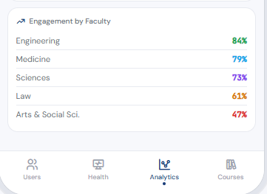
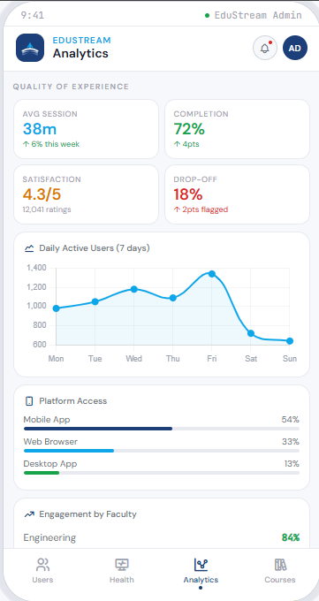
Faculty Engagement provides a ranked breakdown of participation rates by academic department. Engineering leads at 84%, followed by Medicine at 79%, Sciences at 73%, Law at 61%, and Arts & Social Sciences at 47%.

Course & Content Supervision
The Course Supervision module gives administrators oversight of the entire course catalogue which monitors content quality, tracking enrolment patterns, and managing flagged materials that require review or intervention.
The four-summary metrics at the top capture the current state of the catalogue. Total Courses (847) represents the full breadth of available learning content across all faculties. Under Review (24) are courses currently in the approval pipeline, either newly submitted by lecturers or flagged for curriculum reassessment. Published (798) are live courses actively accessible to enrolled students. Flagged (5) are courses that have been identified by the platform's AI quality-check system or by human reviewers as requiring urgent attention.
The Top Enrolled Courses ranking is the centrepiece of this section. Dr. Nkemeni Valery's Mobile Application Development course holds the number one position with 155 enrolled students, highlighted with a gold badge and an accented card to distinguish it from the rest of the list. It carries the highest rating of any course on the platform at 4.9 out of 5, making it both the most popular and the highest-rated course which is a strong indicator of both content quality and relevance to students' career interests. Following it are Intro to Machine Learning by Dr. Amara Okonkwo (148 enrolled), Organic Chemistry II by Dr. P. Biya (137 enrolled), Constitutional Law by Prof. Elangwe (129 enrolled) and Advanced Calculus by Dr. F. Njoku (112 enrolled). The cluster of technology and applied science courses in the top positions reflects broader student demand trends consistent with the Engineering and Sciences faculty engagement figures seen in the analytics module.
The Flagged for Review section currently contains two active items flagged by the AI Quality Check system for containing outdated curriculum content that references 2018-era material. This requires the assigned lecturer to update the course content to current standards. ENG 204 has been flagged by the automated plagiarism detection system because assessment submission similarity scores have exceeded the allowed threshold, indicating a potential academic integrity issue that requires the administrator to investigate and liaise with the relevant faculty.
These two flagged items illustrate the two categories of quality risk the platform monitors: content quality (outdated or inaccurate material) and academic integrity (assessment fraud or misconduct). Addressing both promptly maintains the academic credibility of the institution's e-learning offering and ensures that the quality of experience metrics in the analytics module continue to improve over time.

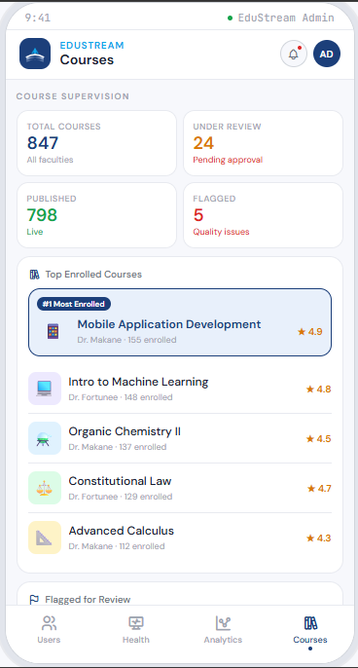
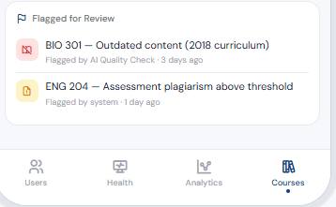

Instructor’s Pannel

Overview of the Instructor Dashboard
The Instructor Dashboard is the main home screen that instructors see when they log into the Adaptive E-learning Platform. This screen serves as a central hub where instructors can quickly access important information about their courses, monitor student engagement, and upload new educational content. The dashboard provides a comprehensive summary of teaching activities in one unified view.

Header and Welcome Section
At the top of the screen, instructors are greeted with a personalized welcome message. The header displays the instructor's name (for example, "Dr. Sarah Anderson") along with their profile avatar. This creates a personalized experience that makes instructors feel recognized within the system. The header remains visible as instructors scroll through the page, ensuring they always know which account they are logged into.

Statistics Overview Cards
Immediately below the header, instructors see three important statistics cards that provide at-a-glance insights into their teaching performance:
- Active Learners: Shows the total number of students currently engaged with the instructor's courses. This helps instructors understand their reach and student engagement levels.
- Total Uploads: Displays the cumulative number of learning materials (videos, notes, quizzes, audio files) that the instructor has uploaded to the platform. This gives a sense of content volume created.
- Average Completion Rate: Indicates the average percentage of course material that students have completed across all the instructor's courses. This metric helps instructors gauge whether their course content is engaging and being completed.

Your Courses Section
The "Your Courses" section displays all the courses that the instructor is currently teaching. Each course is shown as a card containing the following information:
Course Title: The name of the course being taught (e.g., 'Introduction to Web Development')
Number of Students: How many students are enrolled in that particular course
Progress Bar: A visual indicator showing what percentage of the course content has been completed by students on average (ranging from 0% to 100%)
Last Updated: The date when the course content was last modified, helping instructors track when they last made changes

Instructors can tap on any course card to view more detailed information about that course, including student progress, individual student performance, and other course-specific analytics. The visual progress bars allow instructors to quickly identify which courses need attention and which are progressing well.

Recent Uploads Activity Feed
The "Recent Uploads" section provides a timeline of the instructor's recent content uploads to the platform. This serves as an activity log showing:
- Content Type: What type of material was uploaded (video lecture, audio recording, study notes, or quiz assessment)
- Content Title: The name given to the uploaded material
- Associated Course: Which course the content was added to
- Upload Timestamp: When the content was uploaded (e.g., '2 hours ago', '1 day ago')
- File Size: The size of the uploaded file, helping instructors understand their content storage usage
This activity feed helps instructors keep track of what content they have shared with students recently and verify that uploads were successful. Each upload entry can be tapped to access more options such as editing metadata, deleting content, or viewing which students have accessed that material.
Content Upload Options
When instructors tap the upload button, a modal window slides up from the bottom of the screen, presenting four content upload options:
- Video Content: For uploading course lecture videos, demonstrations, and educational video materials
- Audio Content: For uploading recorded lectures, podcast-style content, or supplementary audio materials
- Study Notes: For uploading PDF documents, text files, slides, and other written learning materials
- Quiz/Assessment: For creating quizzes, tests, and assignment assessments for students

Each upload type option displays an icon, title, and brief description to help instructors quickly select what they want to upload. When an instructor selects one of these options, they are taken to the detailed upload form for that content type.

Overall User Experience Benefits
The Instructor Dashboard provides several key benefits to improve the teaching experience:
- Quick Overview: All critical information is visible at a glance without excessive scrolling
- Easy Navigation: The interface is intuitive and requires minimal training to use effectively
- Real-time Updates: Statistics and activity feeds update automatically to reflect current platform status
- Quick Actions: The floating upload button ensures content upload is always just one tap away
- Performance Tracking: Visual progress bars and completion rates help instructors monitor student engagement
- Professional Appearance: The clean, organized layout creates a professional and trustworthy platform appearance

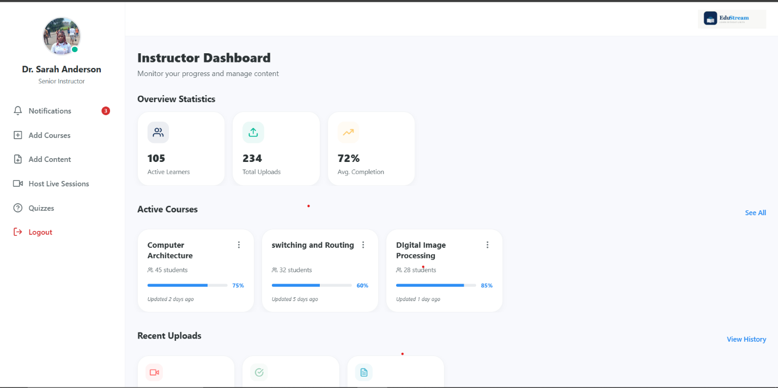

Conclusion
The Instructor Dashboard is a well-designed central hub that gives instructors everything they need to manage their courses effectively. By presenting key metrics, recent activities, and quick access to upload functionality in a single, organized view, the dashboard enables instructors to spend less time navigating the platform and more time focusing on teaching and student engagement. The interface is responsive, accessible on mobile devices, and designed to work efficiently even on slower internet connections through intelligent content optimization.

Student Panel:
The dashboard follows a Single Page Application (SPA) architecture, enabling seamless navigation between pages without requiring browser refreshes. This approach improves user experience, responsiveness, and performance while maintaining a professional academic interface. In its configuration, React was selected because it provides reusable UI elements and fast rendering through the Virtual DOM. While, vite because it provides fast development server startup, Hot Module Replacement (HMR) and simplified project configuration.
We enabled routing with React Router DOM
Because, it manages page navigation without reloading the application.
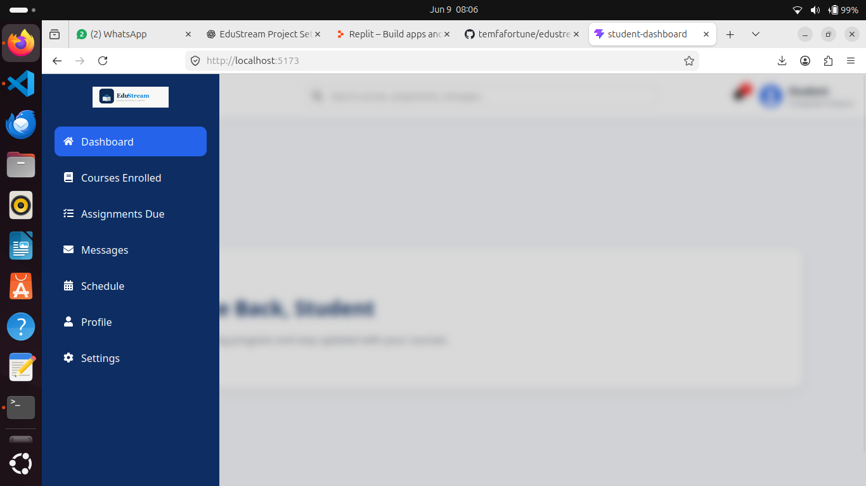
All icons used, were by the use of React Icons including:
- Navigation icons
- Notification indicators
- User profile symbols
- Course and assignment identifiers
Finaly, styling with CSS3 creating a responsive layout, an animated sidebar with transitions, blur effects and a card-based interface.

User Interface Design
From the saying ‘the best design is no design’ stemming from the 10 principles of design, the interface follows a minimalist design approach with primary objectives of:
- Reduce visual clutter
- Improve readability
- Provide clear navigation
- Maintain academic professionalism
- Support mobile responsiveness
Instead of overwhelming students with large amounts of information on the home page, functionality is distributed across dedicated pages.
- Navigation Structure
- Top Navigation Bar
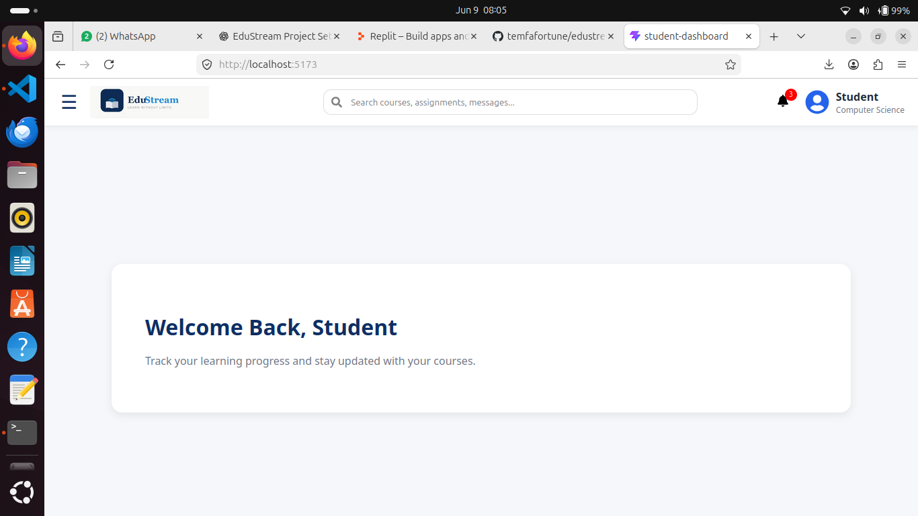
The navigation bar remains visible throughout the application and contains the Menu Button (☰) which opens the sidebar and provides access to all pages. Combined with our EduStream Logo thereby improving recognition creating a professional appearance

The dashboard acts as a landing page after successful authentication. The students can then navigate to dedicated pages for detailed information, like:

Courses Page

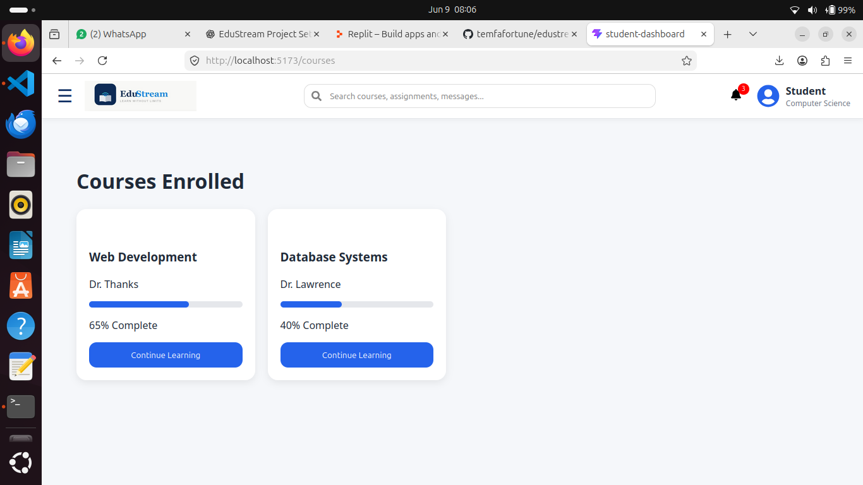

Assignments Page
The Assignments page presents coursework in tabular form, with colour coding to aid students to quickly identify priorities, monitor submissions and void missed deadlines.

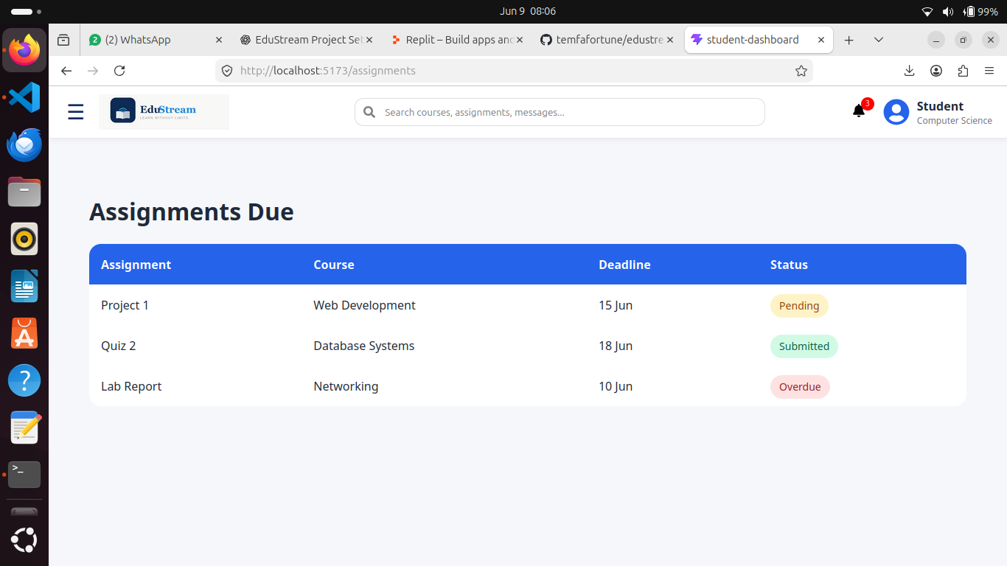

Messages Page
The Messages section provides communication functionality displaying information such as the lecturer communicating course updates and other academic announcements. And the presence of a schedule page is simply to help the student manage their time wisely.
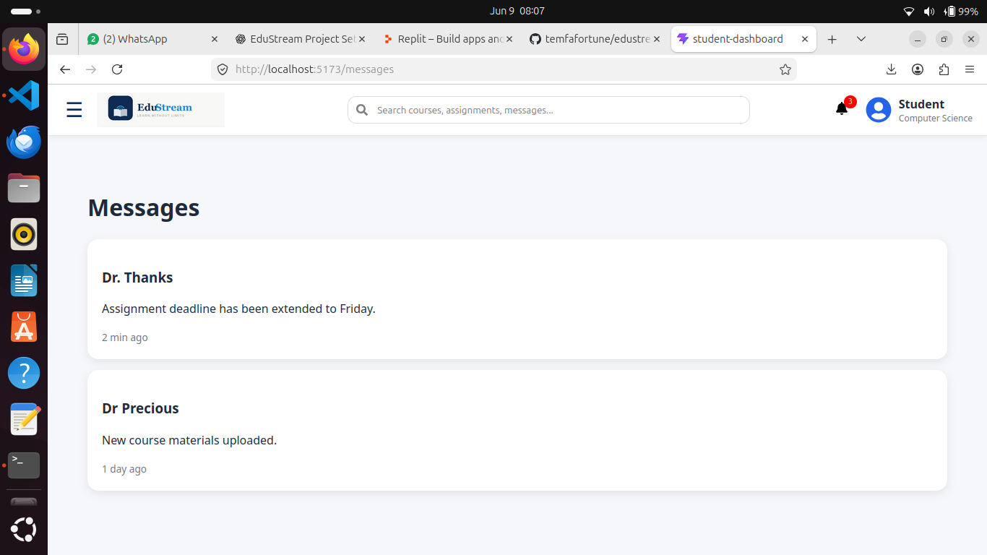

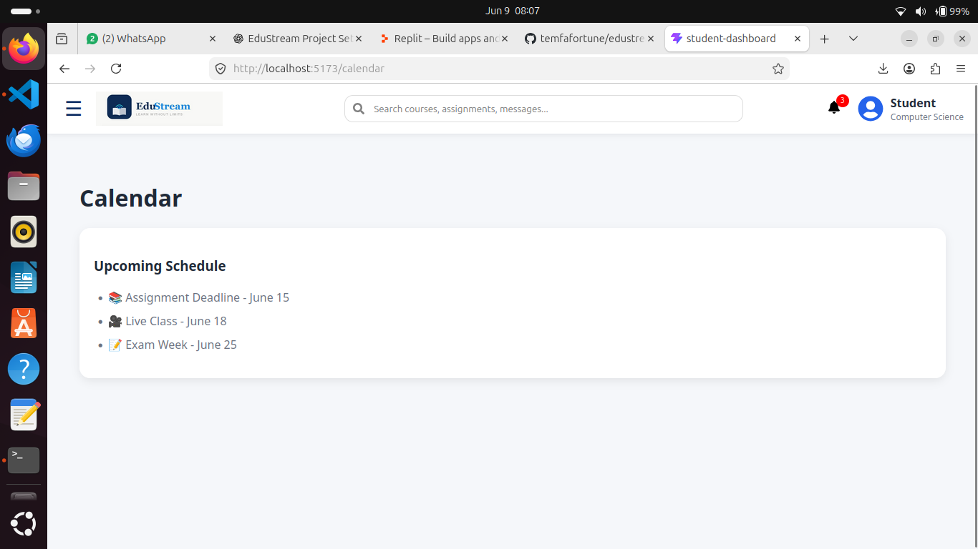

Upon investigation, the colours used:
- #0E2E63: In other words, dark blue, communicates trust, professionalism, stability and academic credibility
- #3498DB (Bright Blue): Providing a visual contrast while maintaining consistency
- #F5F7FA: As background, reduces eye strain, enhances readability generally creating a sort of visual cleanliness.
- #FFFFFF: White cards improve content separation and visual hierarchy.
- Primary Text: #1F2937 and secondary Text: #6B7280; For strong readability while preserving a clean modern aesthetic.
And for status colours:
- Green (#10B981): Success and completion
- Yellow (#F59E0B): Pending actions and arnings
- Red: Urgent items or verdue tasks

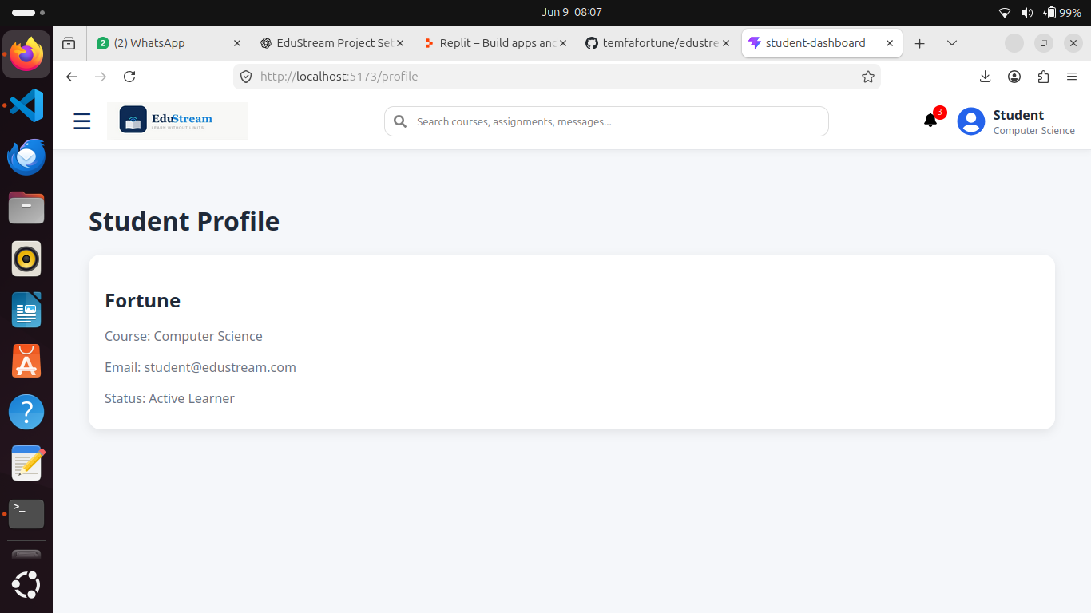
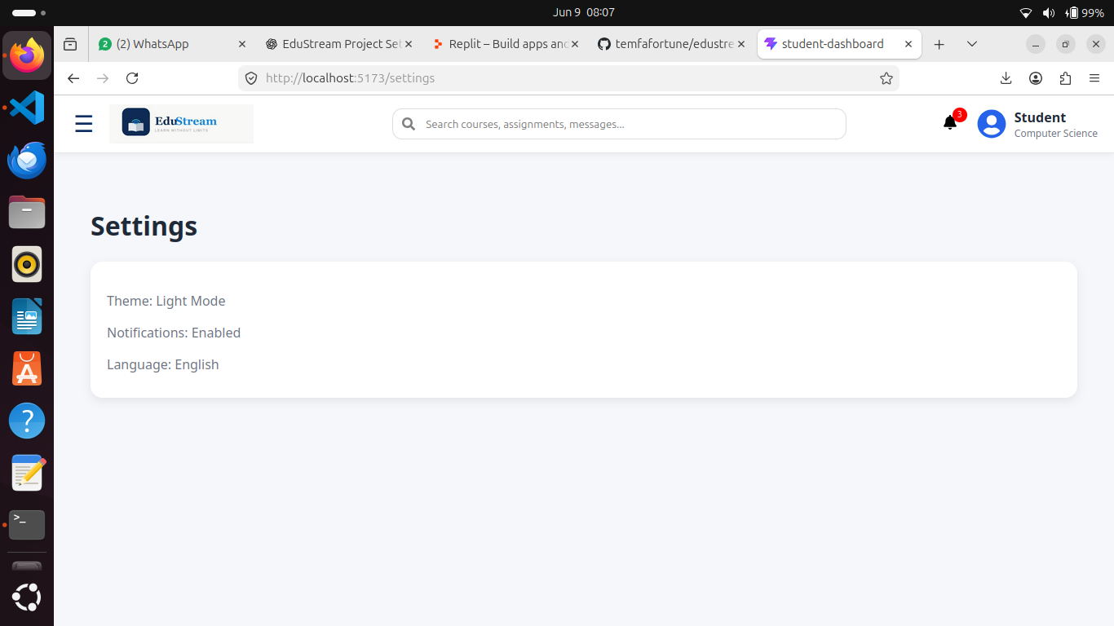

Conclusion

The UI design and implementation of EduStream's application identity successfully establishes a cohesive, purposeful, and accessible digital learning platform. Through a carefully considered visual language anchored by the Deep Navy Blue and Vibrant Sky-Blue palette, Poppins typography and the adaptive streaming icon, the platform communicates academic credibility while remaining approachable and inclusive for users in low-resource connectivity environments.

The three core panels, namely the Admin Dashboard, Instructor Panel, and Student Panel, each address the distinct needs of their respective users while maintaining a unified design system. Administrators gain full operational oversight across user governance, system health, analytics, and course supervision. Instructors benefit from a streamlined content management hub that reduces platform navigation time. Students are served by a clean, minimalist SPA interface that prioritizes readability, clear navigation, and academic focus.
Collectively, the design decisions made throughout this task: from colour contrast ratios meeting WCAG 2.1 AA standards to mobile-first layouts and context-sensitive micro copy which reflect a platform built not merely for functionality, but for real-world usability. EduStream is positioned to deliver on its tagline: Learn Without Limits.

By using Clean Architecture, the "heart" of EduStream (its adaptive learning logic) is protected from external changes and by using MVVM, you ensure that the "face" of EduStream (its minimalist, professional UI) remains fast, responsive, and easy to maintain. Together, they provide the technical foundation to truly Learn Without Limits.

